Method and System for Encoding and Decoding Authentication Data Using Color and Symbol Pairs for Human-Friendly Communication and Validation
Inventor: Bobby Simpson
Filed as: Provisional Patent Application

1. FIELD OF THE INVENTION
This invention relates to the field of cryptographic authentication and human-computer interaction, and more particularly to systems and methods for encoding digital authentication data such as Time-based One-Time Password (TOTP) seeds into human-friendly formats using pairs of colors and symbols optimized for voice transmission, accessibility, and visual clarity.

2. BACKGROUND OF THE INVENTION
TOTP and other cryptographic authentication methods are widely used for two-factor and multi-factor authentication. However, exchanging seed data or validation codes often requires alphanumeric strings that are difficult to communicate accurately over voice or non-digital channels. Traditional encoding schemes (e.g., Base32) are not optimized for accessibility, visual verification, or verbal clarity.

There exists a need for a method that allows authentication codes and seeds to be encoded into a representation that is easily spoken, heard, written, or visually recognized — suitable for use over phone calls, in accessibility contexts, or in offline environments.

3. SUMMARY OF THE INVENTION
This invention introduces a method for encoding digital values (such as bytes from a TOTP seed or one-time-use key) into discrete pairs of color and symbol combinations, where each pair corresponds to an 8-bit or multi-bit index. These pairs are chosen from carefully curated sets of:
- Colors: visually distinct and phonetically clear (e.g., Red, Orange, Blue)
- Symbols: limited to easy-to-distinguish characters (e.g., A, E, F, J, P)

Each color-symbol pair maps to a numerical index that can be decoded deterministically. The encoding includes optional embedded validation checks (e.g., CRCs per group of data) to allow for human-friendly error detection. The entire system can operate:
- Offline
- With only voice (e.g., read aloud)
- With or without technology (paper reference cards)

4. DETAILED DESCRIPTION OF THE INVENTION
4.1 Data Encoding
- The input (e.g., a TOTP seed) is segmented into 8-bit or multi-bit blocks.
- Each block is mapped to a unique color-symbol pair using predefined ordered sets.
- Example: Index 35 → Color: Blue (5), Symbol: F (3), based on: Index = ColorIndex × SymbolCount + SymbolIndex

4.2 Error Detection (Optional CRC Encoding)
- For every 3 pairs (24 bits), a 4th pair is added that encodes an 8-bit CRC calculated over the previous 3.
- This provides a group-validating structure (e.g., 3+1 encoded blocks) for real-time validation.

4.3 Decoding
- The receiver selects color and symbol values using a UI or paper chart.
- These are converted back into index values and then back to the original binary.
- CRC is verified automatically or manually to confirm validity.

4.4 Voice Optimization
- Colors and symbols are chosen to be phonetically distinct.
- NATO phonetic alphabet is associated with each symbol to improve clarity (e.g., "P as in Papa").
- Tooltips, UI elements, and printed aids assist in use by visually impaired or colorblind users.

4.5 Applications
- Secure transfer of authentication seeds via phone
- Recovery code delivery through human-only channels
- Visually verifiable token distribution in low-tech environments
- Covert or mnemonic exchange of cryptographic codes

5. EXAMPLES
Example 1: Encoding a 6-byte TOTP seed
- Input: A1 B2 C3 D4 E5 F6
- Encoded: 3 groups of 3 data pairs + 1 CRC pair → 12 total pairs
- Each pair (e.g., Yellow–S) can be spoken, visualized, or printed

Example 2: Decoding and validation
- User selects "Red–P, Blue–F, Orange–H" → CRC: Green–J
- System or reference sheet confirms valid group

6. CLAIMS (INFORMAL)
1. A method for encoding binary data into human-readable and human-verifiable color-symbol pairs.
2. A method as in claim 1, wherein each pair uniquely represents an 8-bit value.
3. A method as in claim 1, wherein a validation pair is added using a cyclic redundancy check.
4. A method as in claim 1, wherein color and symbol sets are optimized for phonetic clarity and accessibility.
5. A system comprising software and/or physical artifacts that facilitate encoding, decoding, and validating said color-symbol sequences.

7. DRAWING DESCRIPTIONS
Figure 1: Grid layout showing mapping of index values to color-symbol pairs
Figure 2: Example encoded sequence with CRC blocks
Figure 4: Visual decoder UI with dropdowns and group border color feedback

8. ABSTRACT
A method and system for encoding binary data, such as TOTP seed values, into sequences of color and symbol pairs optimized for human voice transmission, visual validation, and accessibility. The invention allows for offline, low-tech, or verbal exchange of authentication data with built-in validation structures using cyclic redundancy checks.

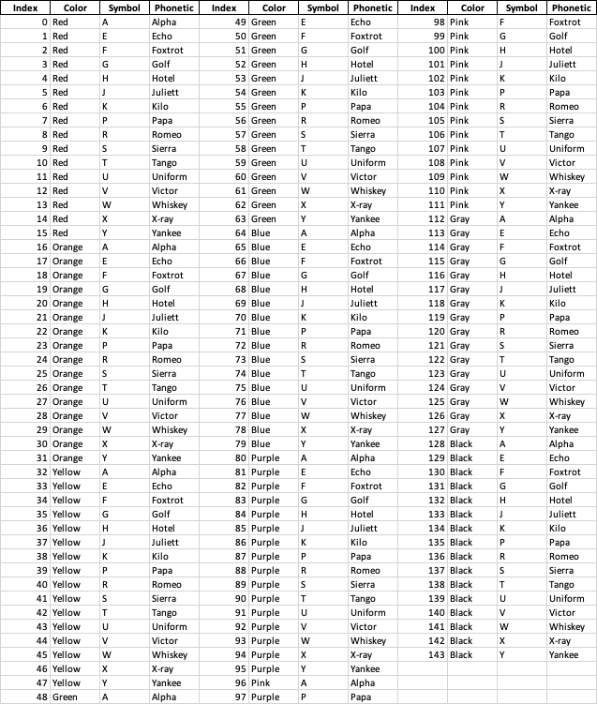
Figure 1 – Mapping numbers to color/letter combinations
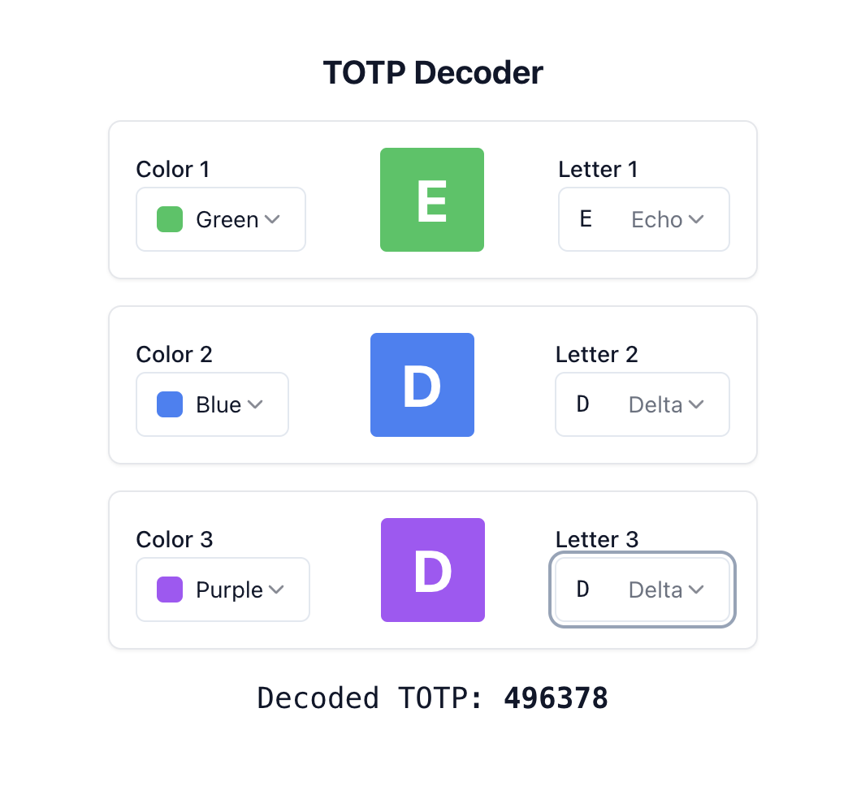
Illustration - Decoder UI
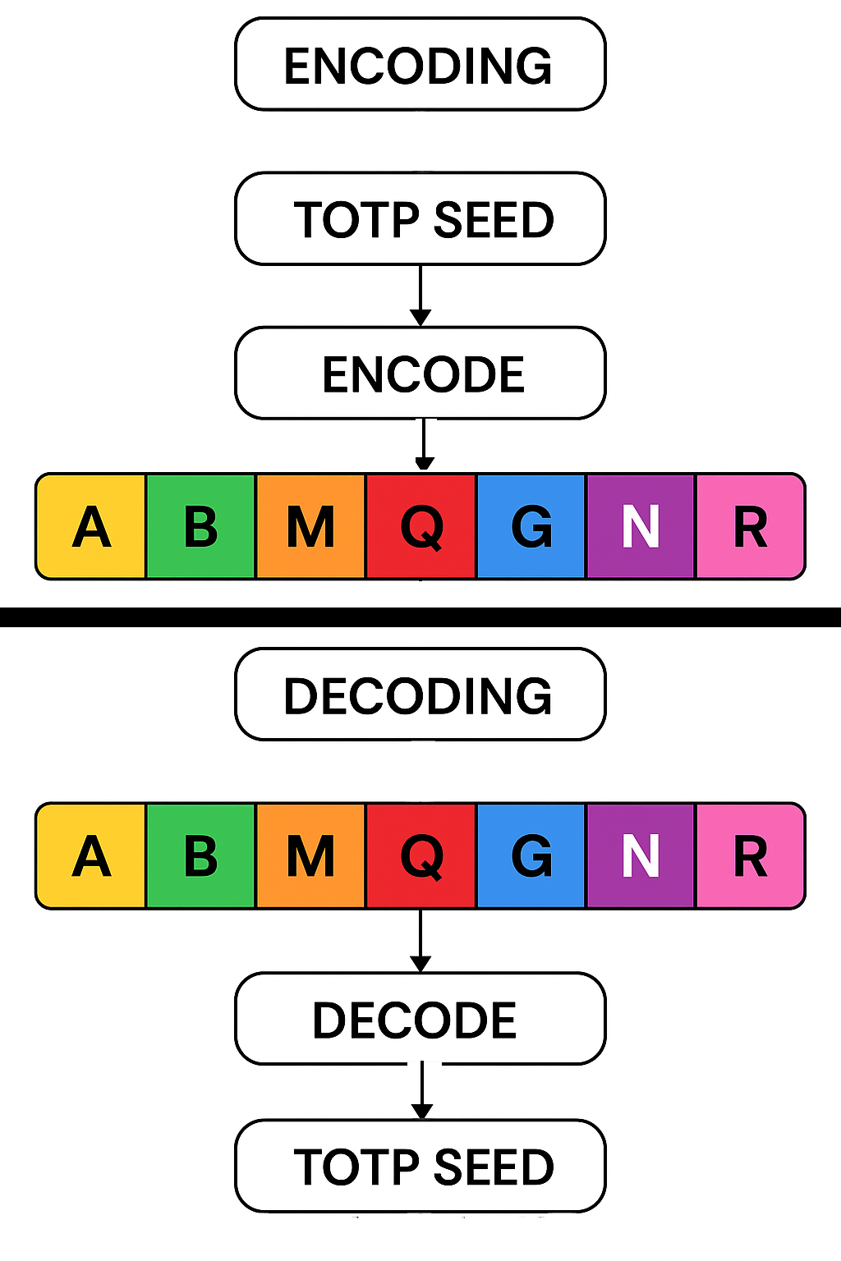
Illustration – Encode Decode

